Using Bloom’s Taxonomy for Objective Development
The Taxonomy of Educational Objectives, often called Bloom's Taxonomy, is a classification of the different objectives and skills that educators set for students (learning objectives). The taxonomy was proposed in 1956 by Benjamin Bloom, an educational psychologist at the University of Chicago. Bloom's Taxonomy divides educational objectives into three "domains:" Affective, Psychomotor, and Cognitive. Like other taxonomies, Bloom's is hierarchical, meaning that learning at the higher levels is dependent on having attained prerequisite knowledge and skills at lower levels (Orlich, et al. 2004). A goal of Bloom's Taxonomy is to motivate educators to focus on all three domains, creating a more holistic form of education.

During the 1990's a new group of cognitive psychologist, lead by Lorin Anderson (a former student of Bloom's), updated the taxonomy reflecting relevance to 21st century work. The graphic is a representation of the NEW verbiage associated with the long familiar Bloom's Taxonomy. Note the change from Nouns to Verbs to describe the different levels of the taxonomy. The new terms are defined as:

Remembering: Retrieving, recognizing, and recalling relevant knowledge from long-term memory.
Understanding: Constructing meaning from oral, written, and graphic messages through interpreting, exemplifying, classifying, summarizing, inferring, comparing, and explaining.
Applying: Carrying out or using a procedure through executing, or implementing.
Analyzing: Breaking material into constituent parts, determining how the parts relate to one another and to an overall structure or purpose through differentiating, organizing, and attributing.
Evaluating: Making judgments based on criteria and standards through checking and critiquing.
Creating: Putting elements together to form a coherent or functional whole; reorganizing elements into a new pattern or structure through generating, planning, or producing.

Bloom’s taxonomy, originally developed to support assessment, can be used in many different ways, one of which is to assist in the development of learning objectives for an online course.

Bloom’s Level | Asks: | Objective Keywords
Remembering: | Can the student recall or remember the information? | define, duplicate, list, memorize, recall, repeat, reproduce state
Understanding: | Can the student explain ideas or concepts? | classify, describe, discuss, explain, identify, locate, recognize, report, select, translate, paraphrase
Applying: | Can the student use the information in a new way? | choose, demonstrate, dramatize, employ, illustrate, interpret, operate, schedule, sketch, solve, use, write
Analyzing: | Can the student distinguish between the different parts? | appraise, compare, contrast, criticize, differentiate, discriminate, distinguish, examine, experiment, question, test
Evaluating: | Can the student justify a stand or decision? | appraise, argue, defend, judge, select, support, value, evaluate
Creating: | Can the student create new product or point of view? | assemble, construct, create, design, develop, formulate, write

Bloom’s digital taxonomy below, another use interpretation of Bloom’s revised taxonomy, can be used to get ideas on how to apply technology to each of the learning levels.

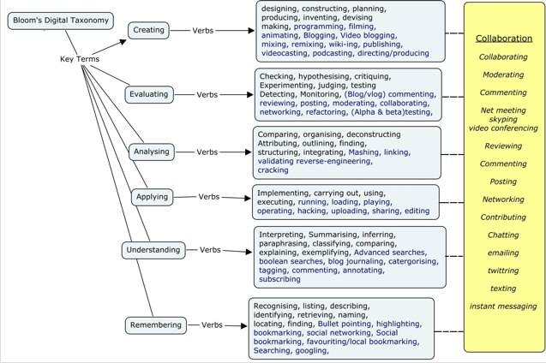

Bloom’s Taxonomy and Objective Development Worksheet
Using the guides above, begin drafting objectives for your online course and include the Bloom’s Taxonomy learning level that you think might be addressed. We will use the objectives and Bloom’s levels here to continue our work in Mapping Your Course: re(Designing) a Course into Modules for Online Delivery.

Objective | Bloom’s Level Addressed

Objective | Bloom’s Level Addressed

Objective | Bloom’s Level Addressed

Based on Bloom’s Taxonomy Wiki. Forehand, Mary, 2008; The University of Georgia; available at http://projects.coe.uga.edu/epltt/index.php?title=Bloom%27s_Taxonomy
Based on Richard C. Overbaugh, Lynn Schultz, Old Dominion University Bloom’s Taxonomy Wiki; available at http://www.odu.edu/educ/roverbau/Bloom/blooms_taxonomy.htm
Bloom's Digital Taxonomy Summary Map available at http://edorigami.wikispaces.com/Bloom's+Digital+Taxonomy

